UDOIT! Information Sharing Policy - 2022

Introduction

We want to ensure children and vulnerable adults are safe.
We accept that from time to time that concerns will need to be shared with/between appropriate organisations to protect them. This information may be about the children or vulnerable adult as well as adults who may be working or volunteering with them. Clubs, organisations and events are holding more and more information about people as a result of good recruitment procedures. This can include criminal record checks, references, application forms etc. We will follow best practice in managing this data in line with current legislation, but recognise that there will be times when, due to a concern, we will share information.
Guidance for sharing information
Where information needs to be shared, we will follow the following rules:
• Data protection is not a barrier to sharing information – but provides a framework to ensure information is shared appropriately
• We will be open and honest with the person from the outset about why, what, how and with whom information will, or could be shared
• Where we are in doubt we will seek advice whilst respecting confidentiality
• We will where possible seek consent before we share information and, where possible, respect the wishes of those who do not consent to share confidential information, but this may not always be possible
• We will base our information sharing decision on considerations of the safety and wellbeing of the person and others whom may be affected by their actions
• We will only share information where it is necessary and with those who need to know and where information can be shared securely. This will include sharing with the statutory services.
• We will keep records of our decision and the reasons for them (Based on Department for Education’s “Information Sharing Pocket Guide”) We will follow the below process in order to decide whether information should be shared.

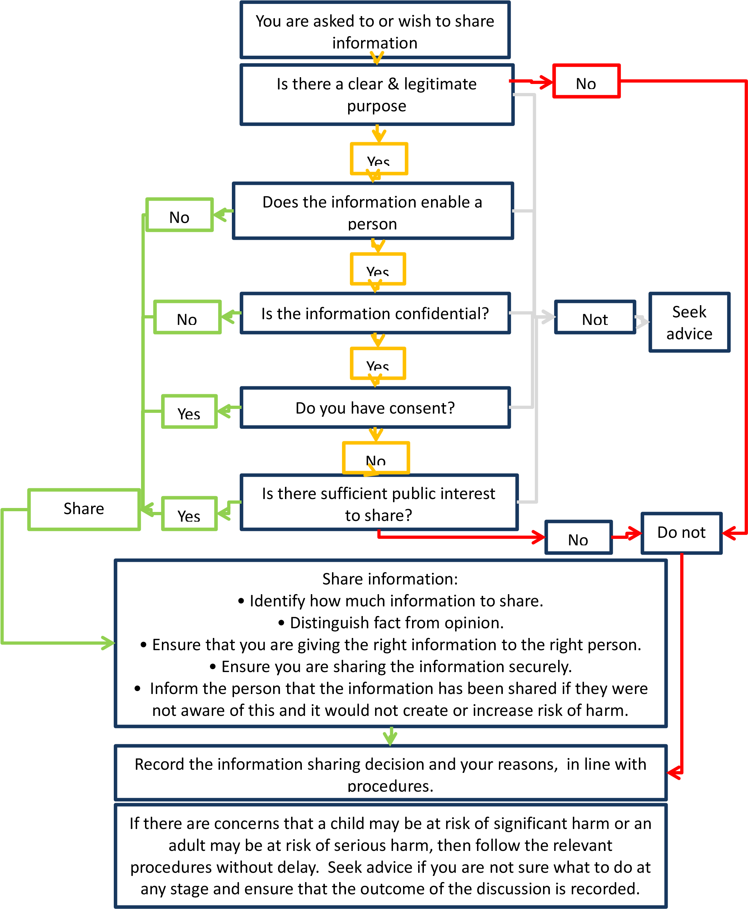

Sharing information arising from concerns about the welfare or safety of a child or young person or the behaviour of an adult or another young person who may represent a risk to them In order to ensure that children and young people are effectively safeguarded it is important that concerns are shared with appropriate people and agencies.
The UDOIT! safeguarding policy clearly identifies the process for information sharing and the need for information to only be shared with those who have a clear need to know.
The Welfare Officer will always be the first port of call. If they are not available then contact will be made with the UDOIT! Safeguarding officer.
Our ultimate concern is the safety of the person, and to protect them from harm. Sharing information arising from recruitment processes
At present there is a limit to the information that can be shared between organisations resulting from Disclosure and Barring Service, Disclosure Scotland or Access NI checks. We are unable to share this information with another sport or County Sport Partnership. Where concerns are raised about an individual that we believe may be of interest to another organisation outside of UDOIT we will use the following wording to communicate our concerns:
“This person has applied to join our organisation in a role that would involve contact with children. As a result of our selection/recruitment process, which includes formal safeguarding checks, he/she has been deemed unsuitable for this post. I strongly suggest that your organisation undertakes a relevant check immediately”
For more information The Data Protection Act
The Data Protection Act provides a framework to ensure that personal information is handled properly; it is not a barrier to sharing information. It gives individuals the right to know what information is held about them. For more information on the Data Protection Act, visit http://www.ico.gov.uk/for_organisations/data_protection.aspx Human Rights Act 1998 The Human Rights Act 1998 gives further legal effect in the UK to the fundamental rights and freedoms contained in the European Convention on Human Rights. These rights not only impact matters of life and death, they also affect the rights people have in their everyday life: what they can say and do, their beliefs, their right to a fair trial and other similar basic entitlements. For more information on the Human Rights Act 1998 visit http://www.equalityhumanrights.com/human-rights/what-are-human-rights/the-human-rights-act/ .
Disclosure and Barring Service The Disclosure and Barring Service (DBS) was formed on 1st December 2012 from a merger between the Criminal Records Bureau (CRB) and Independent Safeguarding Authority (ISA). The DBS was established under the Protection of Freedoms Act 2012 and provides a joined up service to combine the criminal records and barring functions in England and Wales. www.homeoffice.gov.uk/dbs Information Sharing v2 April 2015 Page 4 of 4 1.4 Disclosure Scotland Disclosure Scotland issues certificates – known as ‘Disclosures’ – which give details of an individual’s criminal convictions, or state that they have none. Enhanced Disclosures, where appropriate, will also contain information held by police forces and other Government Bodies. They also manage the Protecting Vulnerable Groups Scheme on behalf of Ministers. http://www,disclosurescotland.co.uk 1.5 Access NI Access NI are responsible for supplying criminal history information, upon request, to organisations and individuals in Northern Ireland, primarily to help them make safer recruitment decisions. http://www.nidirect.gov.uk/accessn

